SCHOOL_________________________________

SCORE _________ RANK_________

Name_______________________________ Name_______________________________

**2018 Rustin Invitational**

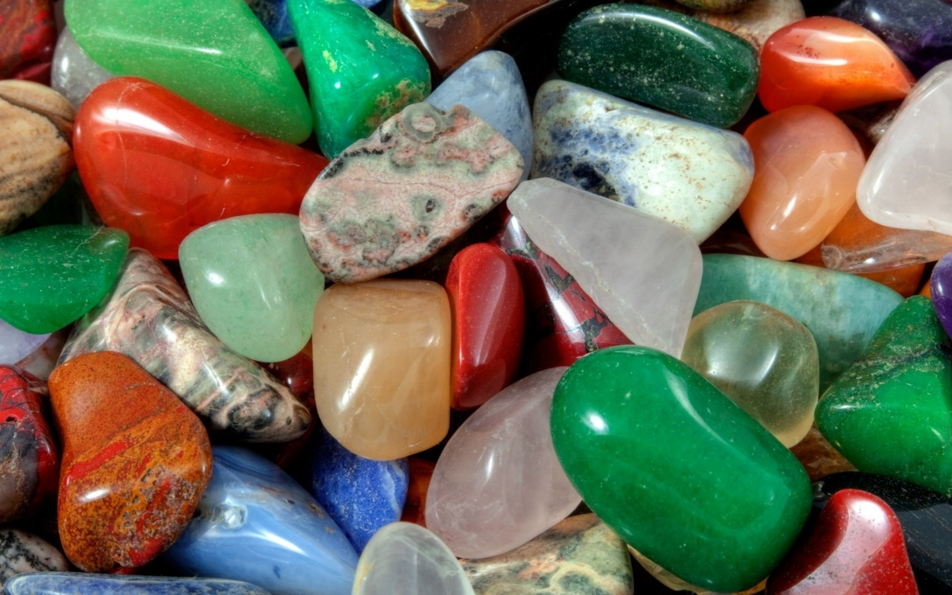

**Station 1**

1. ________

2. ________

3. ________

4. ________

5. ________

6. ________

7. ________

8. ________

**Station 2**

9. ________

10. ________

11. ________

12. ________

13. ________

14. ________

15. ________

16. ________

**Station 3**

17. ________

18. ________

19. ________

20. ________

21. ________

22. ________

23. ________

**Station 4**

24. ________

25. ________

26. ________

27. ________

28. ______ ______ ______ ______

29. ____________________________

30. ________

**Station 5**

31. _________________

32. _________________

33. _________________

34. _________________

35. _________________

**Station 6**

36. __________________________

37. __________________________

38. ________

39. ________

40. ________

41. ___________________________

42. ___________________________

**Station 7**

43. ________

44. ________

45. ________

46. ________

47. ________

48. ________

49. ________

**Station 8**

50. ________

51. ________

52. ________

53. ________

54. ________

55. ________

56. ________

57. ________

**Station 9**

58. ______ ______ ______ ______

59. ________________________

60. ________________________

61. ________

62. ________

63. ________

64. ________

**Station 10**

65. ________

66. ________

67. ________

68. ________

69. ________

70. ________

71. ________

**Station 11**

72. ____________________

73. ____________________

74. ___________________

75. ________

76. ________

77. ________

78. ________

**Station 12**

79. ___________ 80. ________________________

81. ____________ 82. ________________________

83. ___________ 84. ________________________

85. ___________ 86. ________________________

87. __________ 88. ________________________

89. ___________ 90. ________________________

91. ___________ 92. ________________________

|  |  |
| --- | --- |
| 1ST Tie Breaker | Station 12 |
| 2nd Tie Breaker | Station 7 |
| 3rd Tie Breaker | Station 5 |

**Station 13**

|  |  |
| --- | --- |
| Page 1 Total |  |
| Page 2 Total |  |
| Page 3 Total |  |
| Page 4 Total |  |
| Page 5 Total |  |
| Grand Total |  |

93. Identify #16 ________

94. Identify #26 ________

95. Identify #15 ________

96. Identify #31 ________

97. Identify # ________

**Station 14**

98. Identify A ________

99. Identify B ________

100. Identify C ________

101. Identify D ________

102. Identify E ________

**Station 15**

103. Identify A ________

104. Identify B ________

105. Identify C ________

106. Identify D ________

107. Identify E ________